# Introducing HL7 FHIR®

FHIR – **F**ast **H**ealth **I**nteroperable **R**esources ([hl7.org/fhir](http://www.hl7.org/fhir/)) – is a next generation standards framework created by HL7. FHIR combines the best features of HL7’s v2, v3 and CDA product lines while leveraging the latest web standards and applying a tight focus on implementability.

FHIR solutions are built from a set of modular components called “Resources”. These resources can easily be assembled into working systems that solve real world clinical and administrative problems at a fraction of the price of existing alternatives.

FHIR is suitable for use in a wide variety of contexts – from social media on mobile phones through to cloud based solutions and server communication in large institutional healthcare providers.

## Why FHIR is better

FHIR offers many improvements over existing standards:

* Strong focus on **implementation** – fast and easy to implement (multiple developers have had simple interfaces working in a single day)
* as-is, but are easy to adapt and extend to make them suitable for specific needs and circumstances
* Multiple **implementation libraries**, many **examples** available to kick-start development
* Specification is **free for use** with no restrictions
* **Evolutionary development** from HL7 v2 and CDA – standards can co-exist and leverage each other
* Leverages **Web standards** – XML, JSON, HTTP, Atom, OAuth, etc.
* Sand other styles of exchanging information seamlessly
* Specifications are **concise** and can **easily be understood**, including by clinicians
* **Human-readable wire format** for developers
* **Backed by solid ontologies** and rigorous formal mapping for correctness

## Flexibility

A central challenge for healthcare standards is how to handle variability caused by diverse health care processes. Over time, more fields and optionality are added to the specification, gradually adding cost and complexity to the resulting implementations. The alternative is relying on custom extensions. However, traditionally these have been associated with implementation problems too.

FHIR solves this challenge by defining a simple framework for extending and adapting the existing resources. All systems, no matter how they are developed, can easily read these extensions and extension definitions can be retrieved using same framework as retrieving other resources.

In addition, FHIR allows textual, human-readable data as an alternative to structured data, so that existing systems that cannot easily be adapted to all structural features of FHIR, can still participate in FHIR communication.

Resources have been designed with a careful eye to existing systems, to ensure that FHIR aligns well with current products in the market and adding FHIR support to existing systems is therefore relatively painless.

## Example Resource: Patient

For those who would like a peek under the hood, this simple example shows the two important parts of a resource: the standard defined data content and a human readable HTML presentation that is most useful with more complex clinical content.

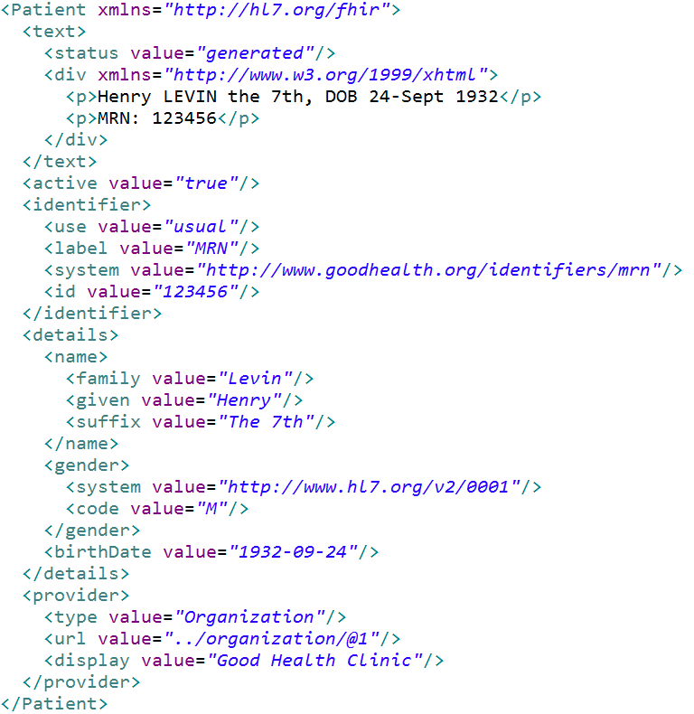

Standard Data   
Content:

* MRN
* Name
* Gender
* Date of Birth
* Provider

Human Readable

Summary

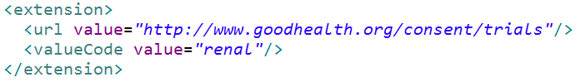

(Add this extension to the example too)

FHIR has resources for administrative concepts such as Patient, Provider, Organization and Device as well as a wide variety of clinical concepts covering Problems, Medications, Diagnostics, Care plans, financial concerns and more.

## The FHIR development process

FHIR is still undergoing development as an HL7 standard. By the end of 2013, FHIR should be available as a Draft Standard for Trial Use. After a period of trial use to bed the specification, HL7 will develop FHIR as a full normative specification, most likely through 2015.

Due to the many advantages FHIR offers, trial use is already beginning right now.

FHIR. [C:\workspace\projects\org.hl7.fhir\publish\flame16.png](http://hl7.org/fhir) <http://www.hl7.org/fhir/>. Follow us on #FHIR